The CiscoPavelka Global Challenge – I’m taking part, are you?

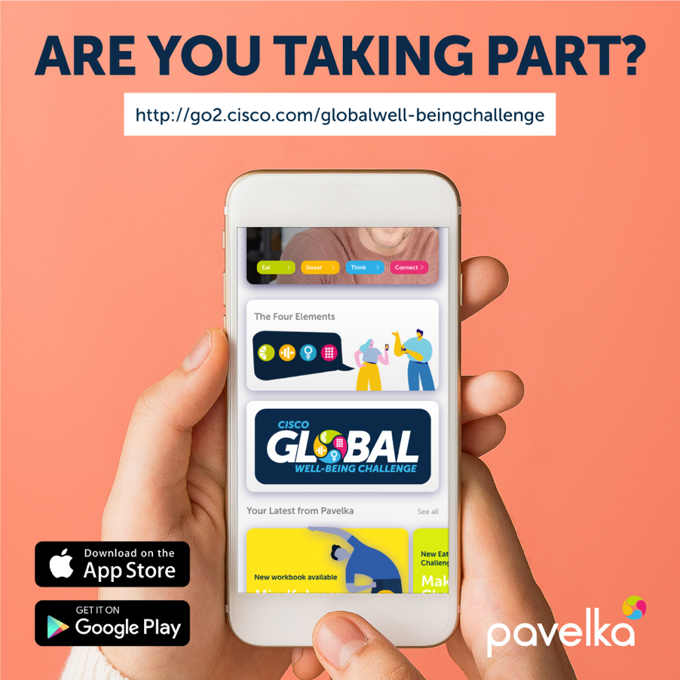

Via the all-new Pavelka app my team of four is shining a light on every day with the Four Elements: Eat, Sweat, Think and Connect. Completing small changes for big results and sharing them with the Cisco community.

Find out more about the challenge, and see how to take part, here.

