I’m taking part - The CiscoPavelka Global Well-Being Challenge is coming soon!

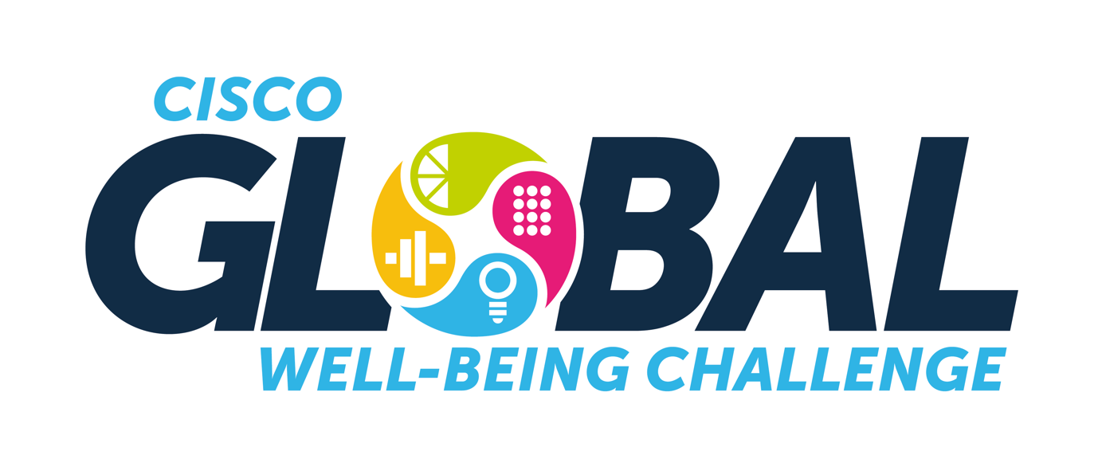

This is where we Connect!

This is who we can be!

This is where healthy collaboration happens!

The CiscoPavelka Global Well-Being Challenge is coming soon – and it’s all about The Four Elements: Eat, Sweat, Think, Connect.

In preparation for the challenge, I am creating a team of four and would love to invite you to take part or even create your own team.

Find out more about the challenge, and see how to take part, here.

